**COLOUR IMAGE ENHANCMENT BASED ON HISTOGRAM EQUALIZATION**

**HISTOGRAM EQUALIZATION**

**It is a process to enhance the quality of a digital image without knowing about the source of degradation.**

**What is histogram**

It is a graph that shows the frequency of anything in image it shows the gray level values of image in a-axis and intensity values of an image in y-axis.

1. Types of Histogram

* 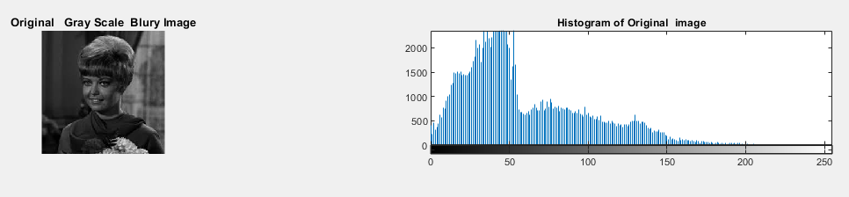**Dark image**

As you can see that on the above image the number of gray level pixel small range and all are near the to zero.

* **Bright image**

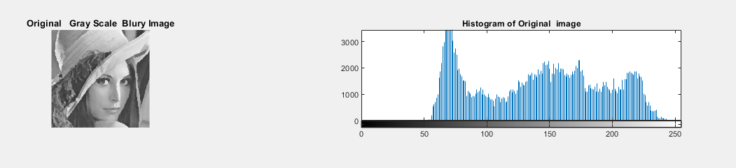

In the above image the number of gray levels at the maximum site so the pixel of the image is bright.

* 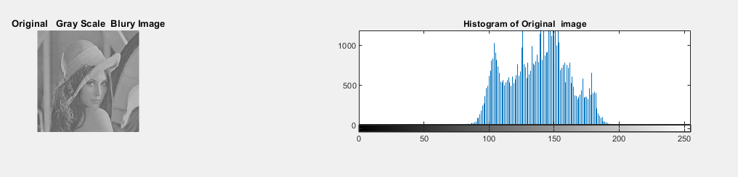**Low Contrast image**

As you can see that in the above image only the small range of gray level is having the contrast varying no.

* 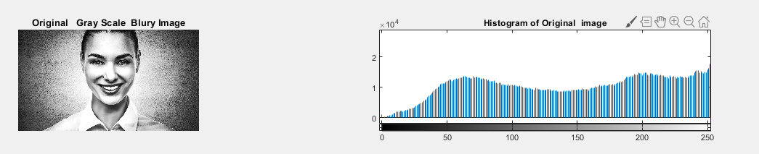**High Contrast**

In the above the image the number of gray level is occupied from 0 to 255 so its mean that the above image is a good contrast image.

**Histogram Equalization:**

It is a process used to enhance the contrast of color image. It is a one the best and simplest method for enhancing the quality of color image.in this method the process image enhancement is divided into two domain the first one is frequency domain and the second one is spatial domain. In frequency domain the operation operates on the frequency transformation of the image and in other hand in spatial domain the technique directly applies on the pixel of the image. As we know that the image enhancement is used to improve the contrast of the image having low luminance. This method removes the distortion from the images and improves the quality of the image. In this method distribute the pixel of the image on the dynamic range for enhance the contrast of the image.

**Classical Histogram Equalization**

**Implementation:**

%Classical Histogram Equalization (CHE)

%f=imread("old_house.jpg");%read gray scale image

%e=imread("color_house.jpg"); % read color image

%subplot(3,2,1),imshow(f,'InitialMagnification', 'fit'), title("Original Gray Scale Image");

%subplot(3,2,2), imhist(f),title("Histogram of Orignal Gray Scale Image");

%subplot(3,2,3),imshow(e,'InitialMagnification', 'fit'), title("Original Color image");

%subplot(3,2,4), imhist(f),title("Histogram of Original Color image");

%As you can see that on the above iamge the pixel are not distributed

%now lets compute the above process on gray scale blury image to enchance

%the quality of the images..

a=imread('low_frequencies.jpg');% Read the gray scale blur image

%imshow(a,'InitialMagnification', 'fit');

%eq1=histeq(a);%Equalized the image

subplot(3,2,1),imshow(a), title("Original Gray Scale Blury Image");

subplot(3,2,2),imshow(eq1), title("Equalized Gray Scale enhanced Image");

subplot(3,2,3), imhist(a),title("Histogram of Original image");

subplot(3,2,4), imhist(eq1),title("Histogram of Equalized image");

Result:

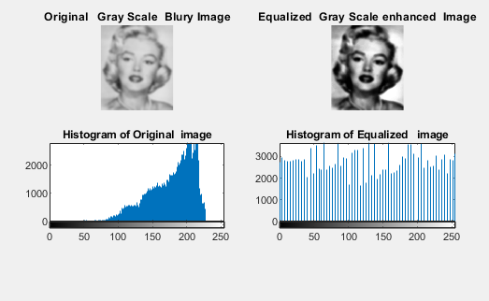

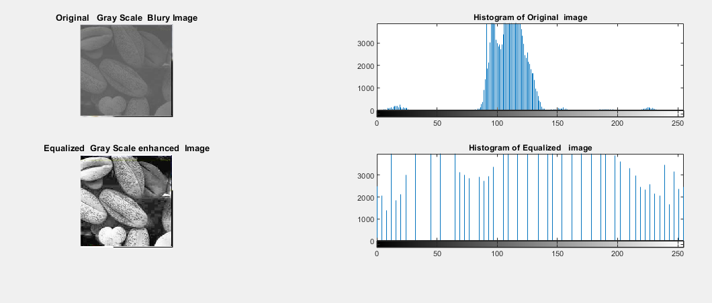

**Back-end process through example**:

|  |  |  |  |
| --- | --- | --- | --- |
| **3** | **4** | **5** | **5** |
| **4** | **4** | **4** | **3** |
| **0** | **0** | **2** | **1** |
| **4** | **5** | **6** | **2** |

Table 1

Gray Level pixel Values

1. Find maximum intensity values in the given table

6 is the maximum gray level values of pixel

6 Binary code of 6=110 now on the 3 bits so we get 111 according to this we can enter maximum intensity value is 7

g =0 1 2 3 4 5 6 7 the maximum intensity values according to our above calculation

|  |  |  |  |  |  |
| --- | --- | --- | --- | --- | --- |
| g | No of g | PMF | CM | 7*CM | Round of |
| 0 | 2 | 0.125 | 0.125 | 0.875 | 1 |
| 1 | 1 | 0.0625 | 0.1875 | 1.3125 | 1 |
| 2 | 2 | 0.125 | 0.3125 | 2.1875 | 2 |
| 3 | 2 | 0.125 | 0.4375 | 3.0625 | 3 |
| 4 | 5 | 0.3125 | 0.75 | 5.25 | 5 |
| 5 | 3 | 0.1875 | 0.9375 | 6.5625 | 7 |
| 6 | 1 | 0.0625 | 1 | 7 | 7 |
| 7 | 0 | 0 | 1 | 7 | 7 |
|  | Sum=16 |  |  |  |  |

1. No of gray level which appear on the table
2. Probability Mass Function (PMF)

**Formula=no of g/sum**

1. Add PMF First two values 0.125=0.125 then 0.125+0.0625=0.1875 and so on…
2. Now maximum intensity multiply by CM 7*CM
3. Round of CM like 0.875=1 and so on
4. Now check the gray level values of in corresponding table 1 and make new table.

|  |  |  |  |
| --- | --- | --- | --- |
| **3** | **4** | **5** | **5** |
| **4** | **4** | **4** | **3** |
| **0** | **0** | **2** | **1** |
| **5** | **6** | **2** | **1** |

Input image

|  |  |  |  |
| --- | --- | --- | --- |
| **3** | **5** | **7** | **7** |
| **5** | **5** | **5** | **3** |
| **1** | **1** | **2** | **1** |
| **5** | **7** | **7** | **2** |

Enhanced image

The above process shows the image enhancement backend story after equalized the image the number of maximum gray level values distribute evenly for getting the better quality of image.

**Drawback:**

In the whole above procedure of histogram equalization, your can see that it confined image in high level and the result of image isn’t good quality it is because its histogram is not confined to a particular region so to solve this problem adaptive histogram is used.

**Contrast Limited Adaptive Histogram Equalization**

This method also uses to enhance the contrast of an image is similar to HE but in this method, we divided the image into two different small parts each part called ‘tiles ‘and get the histogram of each parts and uses to redistributes the brightness values so, the output of this method is same as specified histogram but this method is different from CHE. the disadvantage of this method is that it cannot be regain the brightness as input image.

**Implement:**

%Contrast Limited Adaptive Hisogram Euqlization

m=imread("camera.jpg");

j = adapthisteq(m);

subplot(3,2,1),imshow(m), title("Original Image");

subplot(3,2,2), imhist(m),title("Histogram of Original image");

subplot(3,2,3),imshow(j), title("Contrast Limited Adaptive hisogram equalized image");

subplot(3,2,4), imhist(j),title("Histogram of Contrast Limited Adaptie HG ");

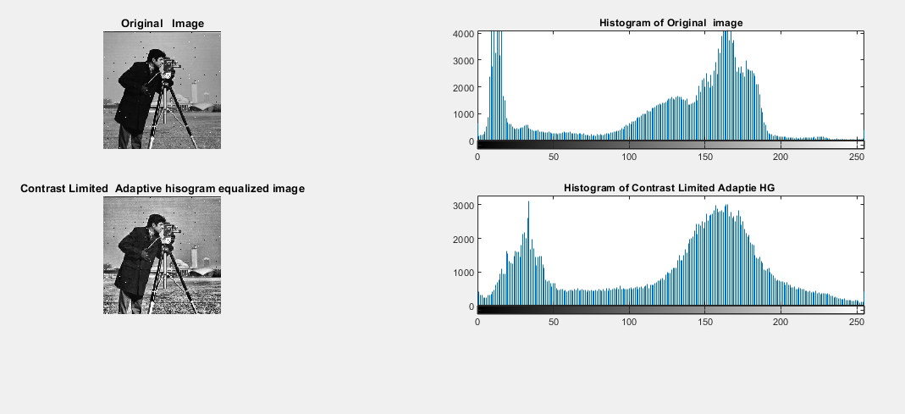

**Brightness Preserving Bi-Histogram Equalization (BBHE)**

Histogram Equalization is simple easy and effective image enhancement technique but there is some drawback with this method because in this method image tends to change the brightness of an image significantly, which causing annoying anticraft and unnatural contrast enhancement, so overcome we this problem we proposed Brightness preserving Bi-Histogram Equalization but still it may fail to good result in some cases.

**Implementation:**